**Deploying containers on Heroku**

Prerequisites:

1. **Heroku** Account
2. **Dockerfile** in your respective microservices (ready to build and push)

**Lets start…**

1. Create app
2. Create DB (Herouku Postgres)

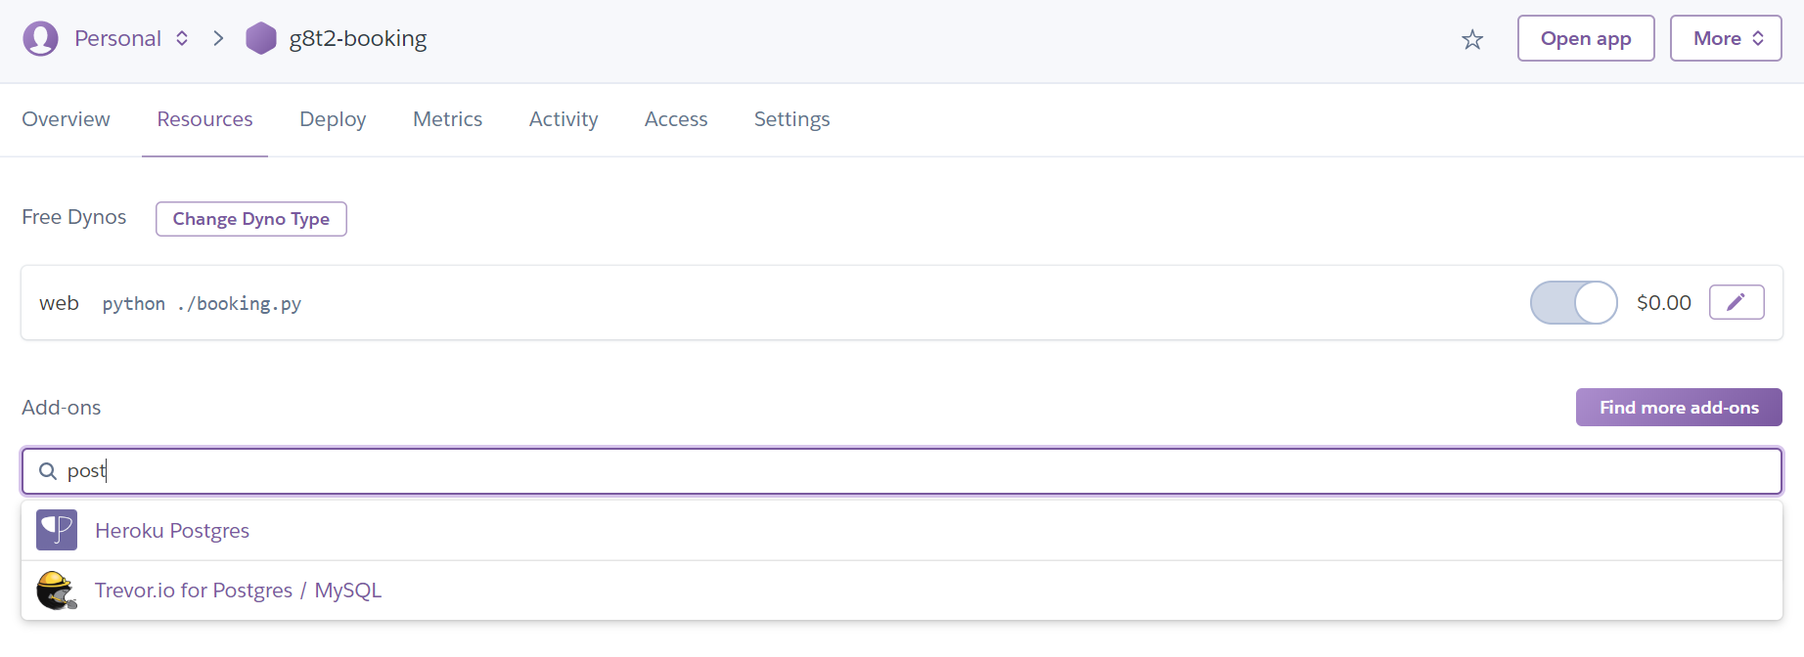

1. Take the endpoint from the DB and put into the .py file SQLALCHEMY_DATABASE_URI

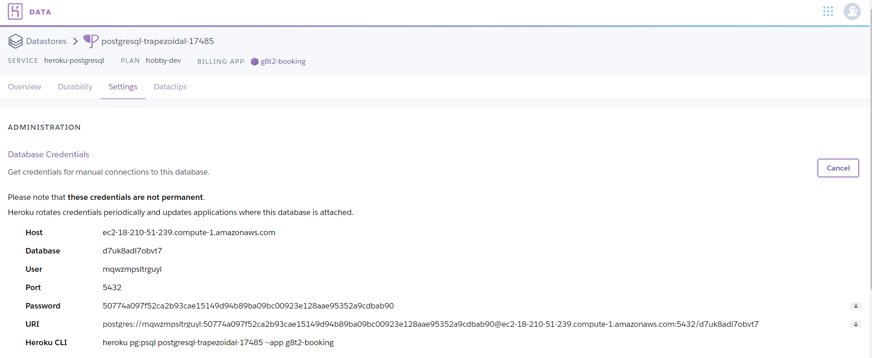

1. Change the URL of the sql connection

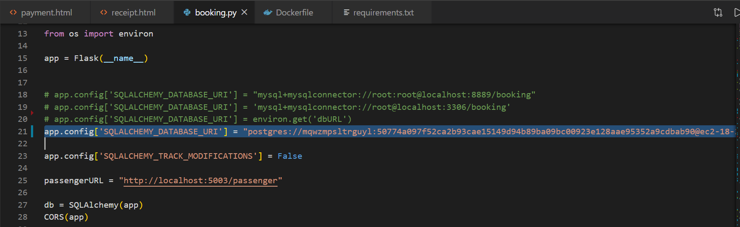

1. Import “OS” and “psycopg2”

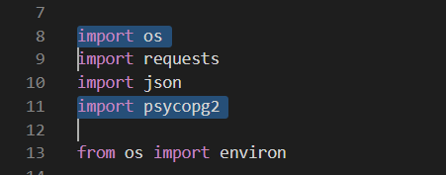

1. Change the port (**now our port will be assigned by heroku, so we need to change our kong API**)

if __name__ == '__main__':

...

    port = int(os.environ.get('PORT', 5000))

    app.run(host='0.0.0.0', port=port, debug=False)

1. Change debug = false

if __name__ == '__main__':

    port = int(os.environ.get('PORT', 5000))

    app.run(host='0.0.0.0', port=port, debug=False)

**Viewing your PostgreSQL DB locally**

Prerequisite:

<https://www.postgresqltutorial.com/install-postgresql/>

1. Open your CLI (command line interface) and use this command (You don’t have to run it in the docker folder)

heroku login

heroku psql -a <heroku app name>

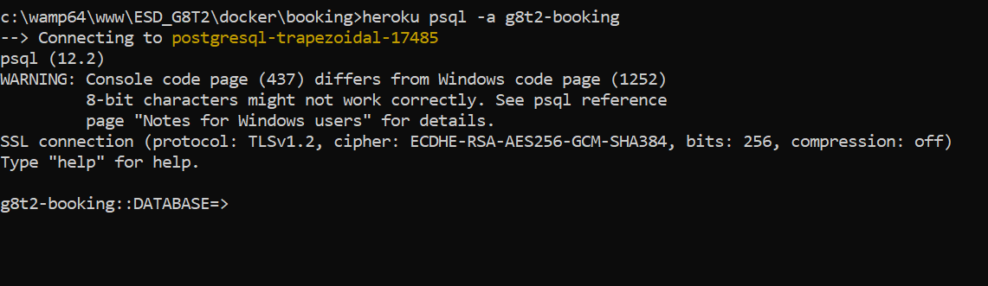

1. Commands (remember actions must end with ;)
   1. Viewing table: \dt
   2. Viewing database: \db
   3. Drop table: DROP TABLE <db_name>;
   4. Creation of database (ASK @XINWEI)

**Getting ready to push to heroku containers**

**Prerequisite**:

Download:<https://pypi.org/project/psycopg2/>

pip install psycopg2

1. **Ensure your requirements.txt is updated with the version of psycorpg2 you downloaded. For me it is,**

**(Just use this for our project)**

psycopg2==2.8.4

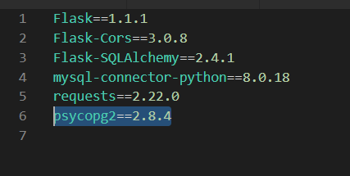

**\*\*CD INTO YOUR DIRECTORY WITH DOCKERFILE BEFORE THE NEXT FEW STEPS\*\***

* If not, you will have “no images to push” error.

1. **Login to heroku**

heroku login

1. **Login to heroku container**

heroku container:login

1. **Push into heroku container your app**

(A cool fact about push;release: <https://devcenter.heroku.com/changelog-items/1426>)

heroku container:push web -a <Heroku app name>

heroku container:release web -a <Heroku app name>

E.g. push

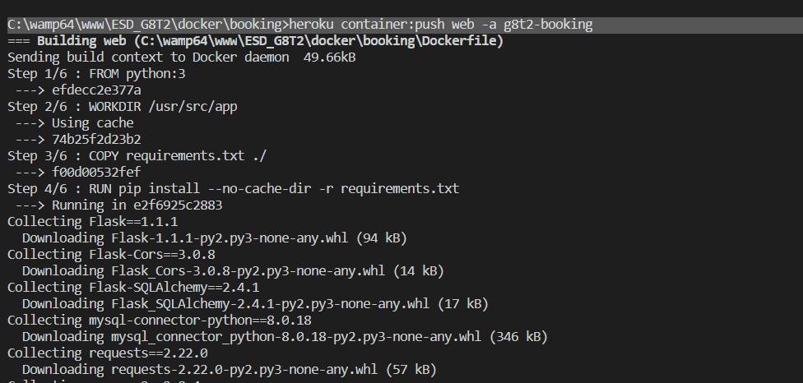

E.g. release



1. ***Check for errors by looking at the logs***

heroku logs –-­tail

**OR**

heroku logs -a <app_name>